|  |
| --- |
| User Manual  Supervisor user (HRM & DM) |
| REFERENCE: GW/ERP/USER MANUAL |
|  |
| **Genweb2 Ltd.** |
| **12-Aug-20** |



|  |
| --- |
|  |

Contents

1. Leave Request 3

1.1 Create Leave Request 3

1.2 Create Leave Allocation Request 5

2. Leave Request Approval by Department Manager/Supervisor 6

2.1 Leave Summary 6

2.2 First Approval Leave Request by Department manager/supervisor 6

3. Second Leave Request Approval by Next Hierarchy Manager or HR manager 8

3.1 Leave Summary 8

3.2 Final Approval and Validate Leave Request by HR Manager 8

4. Leave Allocation Request Approval by Department Manager/supervisor 10

4.1 First Approval Leave Allocation Request by Department Manager/supervisor 10

5. Short Leave Request 10

5.1 Create Short Leave Request 10

6. Short Leave Request Approval by Department Manager/Supervisor 12

6.1 First short Leave Approval Request by Department manager/supervisor 12

7. Attendance 13

7.1 Create Manual Attendance 13

8. Manual Attendance Batches Request Approval by Department Manager/Supervisor 15

8.1 Pending Manual Attendance batches 15

8.2 Approval Manual Attendance Request by Department manager 15

8.3 Create Alter Rostering 16

8.4 Approval Alter rostering Request by Department manager/Supervisor 17

9. OT Requisition 18

9.1 Create a OT Request 19

10. OT Request Approval by Department Manager/Supervisor 20

10.1 First OT Approval Request by Department manager/supervisor 20

# 1. Leave Request

Supervisor/In charge is capable to his/her own leave request. And he/she will approve leave request under his all employee against.

## 1.1 Create Leave Request

For create a leave request we have to go leave menu then create a leave request.

Using the menu **Leave ‣ My Leaves ‣ Leave Request** click **Calendar** button.

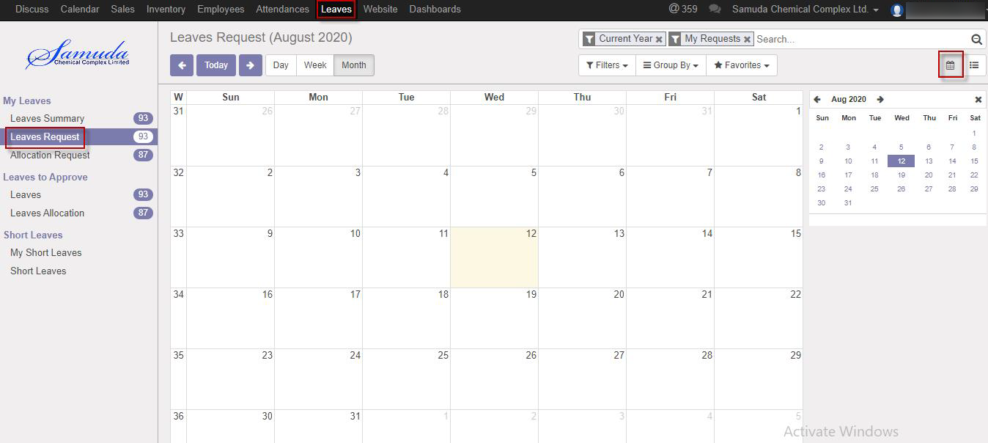

**Fig:** Leave Calendar View

Also we can see using the menu **Leave ‣ My Leaves ‣ Leave Request** click **List** button.

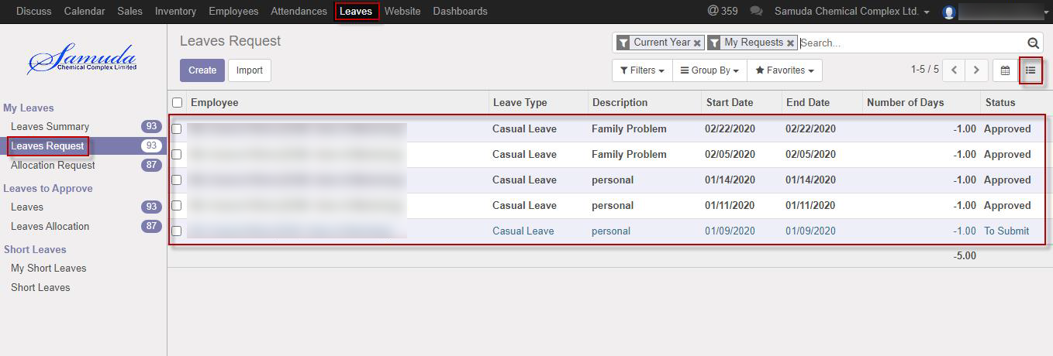

Figure**:** Leave List View

To create new Leave Request, Using the menu **Leave ‣ My Leaves ‣ Leave Request** click **Create**.

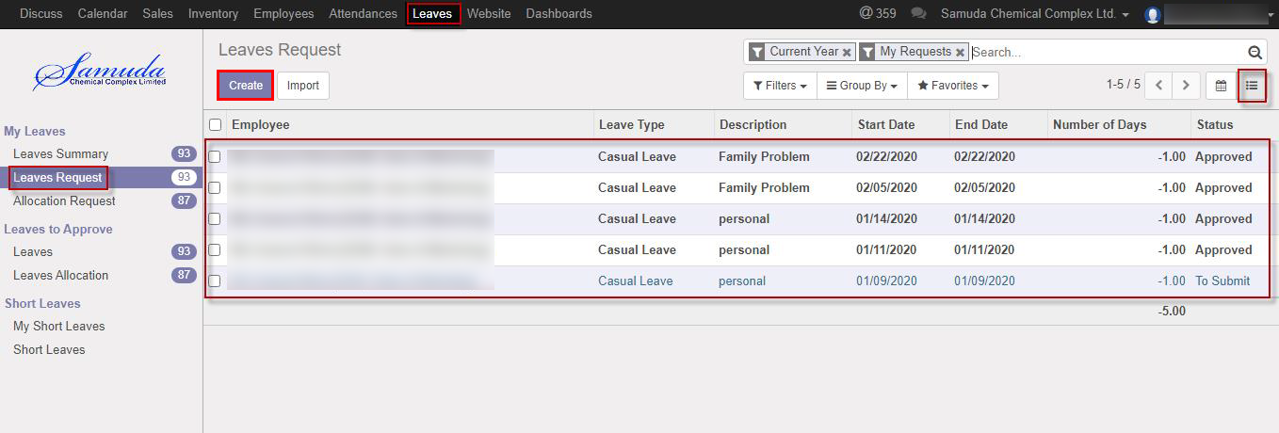

You can set the following information:-

**Description:** Enter some description.

**Leave Type:** Select a leave type.

**Duration:** Select duration of leave.

After entering the Leave Request information click **save**.

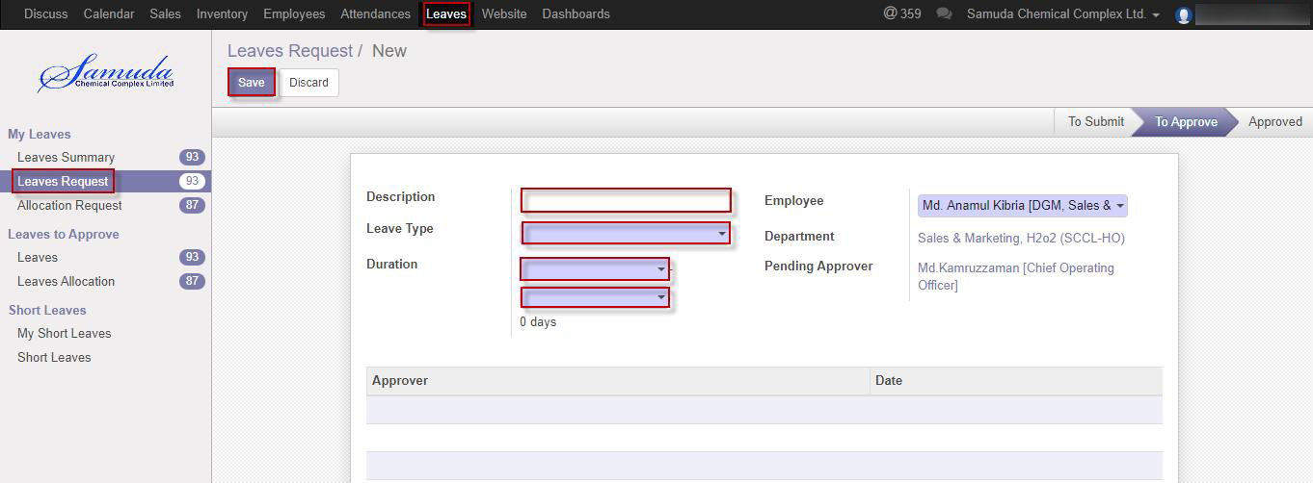

Figure: Create a Leave Request

After apply the leave request respective “Manager/supervisor” will get the notification. Unit HR can approve the leave request. He can update number of leave day(s) before approval. After Manager Approval, Unit HR will get notification. Unit HR Can Approve or Refuse the leave request. After that requested leave will finally approve.

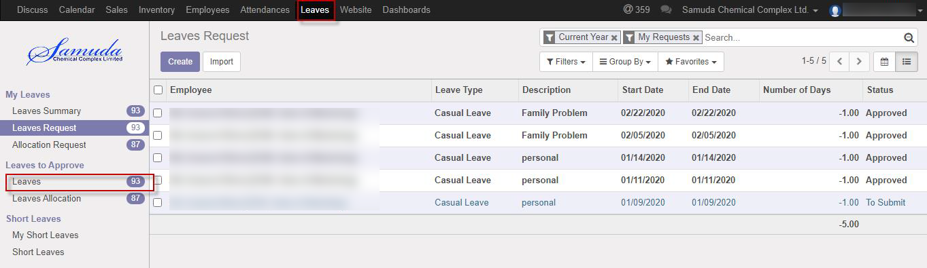

Figure: Leave Request Notification

## 1.2 Create Leave Allocation Request

Supervisor/In charge is capable to his/her own leave allocation request. And he/she will approve leave allocation request under his all employee against.

For create a leave allocation request we have to go leave menu then create an allocation request.

Using the menu **Leave ‣ My Leaves ‣ Allocation Request** click **Create**.

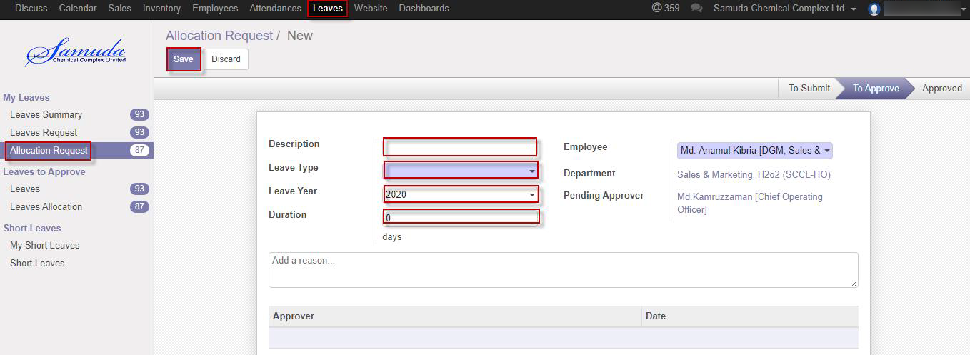

Figure: A Leave Allocation Request

After apply the leave allocation request respective “Manager/supervisor” will get the notification. Unit HR can approve or Refuse the leave allocation request. He can update number of day(s) before approval. After Manager Approval, Unit HR will get notification. Unit HR Can Approve or Refuse the leave allocation request. After that requested leave allocation will finally approve.

# 2. Leave Request Approval by Department Manager/Supervisor

## 2.1 Leave Summary

Only approver hierarchy user can see all of employee leave Summary/Leave allocation/Leave request, if He/she exist in set custom chain level. Which will set to employee profile form.

Using the menu **Leave ‣ My Leaves ‣ Leave Summary**.

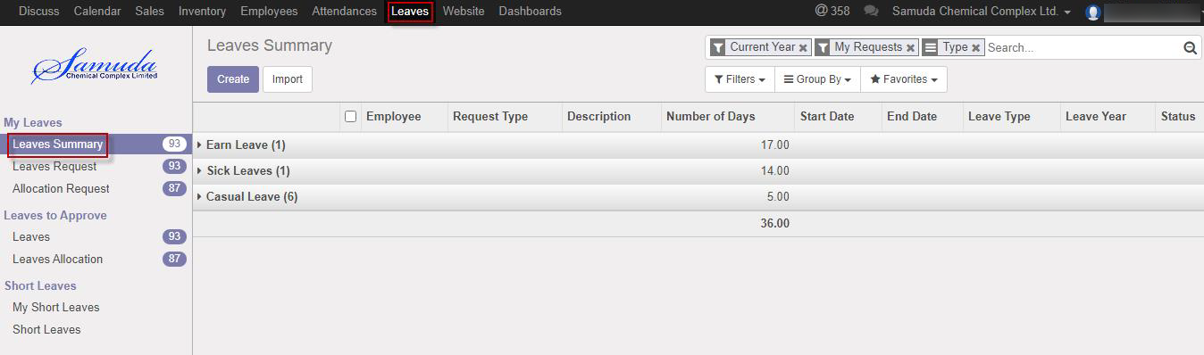

Figure: Leave Summary

## 2.2 First Approval Leave Request by Department manager/supervisor

After apply the leave request “Respective department manager/supervisor” will get the notification. Respective Manager Can first/final approve the leave request. That’s approve will final approve if no other employee none the set custom chain. Respective Management can update number of leave day(s) before approve. After department Manager Approval, Next hierarchy user will get notification.

To see the employee leave request use the menu **Leave ‣ Leaves to approve ‣ Leaves.**

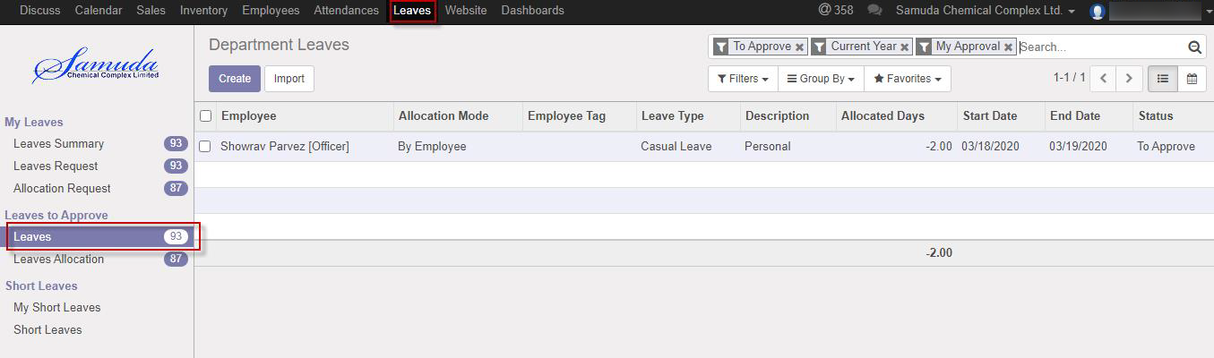

Figure: Leave Request Notification

Department manager/supervisor can approve employee’s leave request. Department Manager can see all leave request there **Leave ‣ Leaves to approve ‣ Leaves** 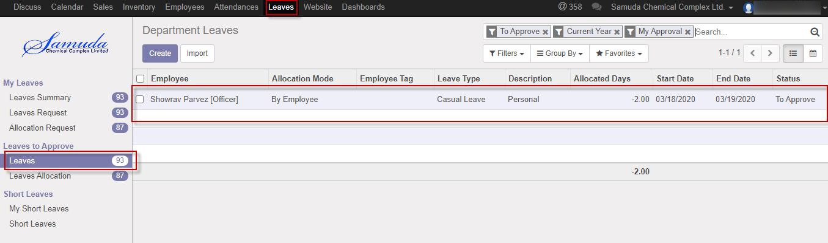

Figure: Leave Request List View

Here Department Manager can first approve the leave request by click on **Approve** button. He can update number of leave day(s) before approval.

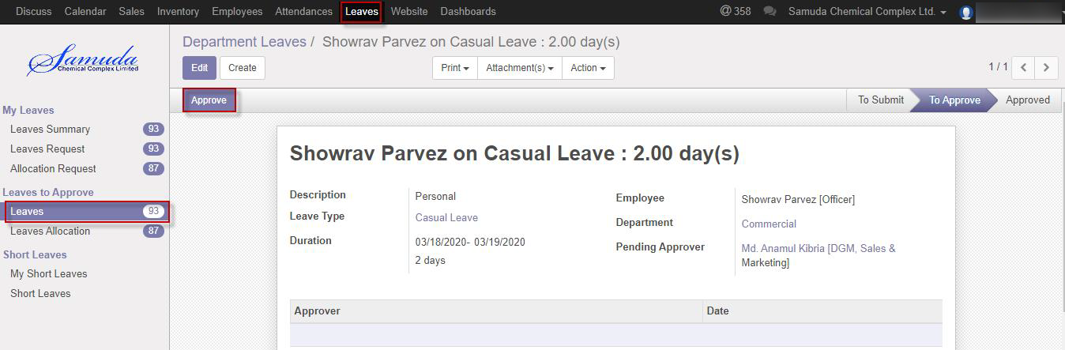

Figure: A Leave Request First Approval

# 3. Second Leave Request Approval by Next Hierarchy Manager or HR manager

## 3.1 Leave Summary

Respective Manager can see all of employee leave Summary.

Using the menu **Leave ‣ My Leaves ‣ Leave Summary**.

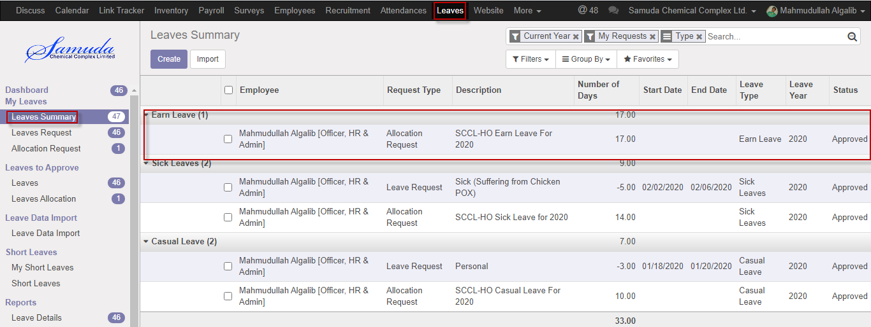

Figure: Leave Summary

## 3.2 Final Approval and Validate Leave Request by HR Manager

After super visor approval, respective manager can second/final approve or refuse the employee’s leave request. Manager can see all leave request there **Leave ‣ Leave to approve ‣ Leaves.**

Here respective Manager Can Final approve the leave request by click on **Approve** button. He can update number of leave day(s) before approval. That’s the way leave will approve hierarchy wise one after another.

Respective manager can refuse leave request by click **Refuse** Button

Respective manager can Validate leave request by click **Validate** Button

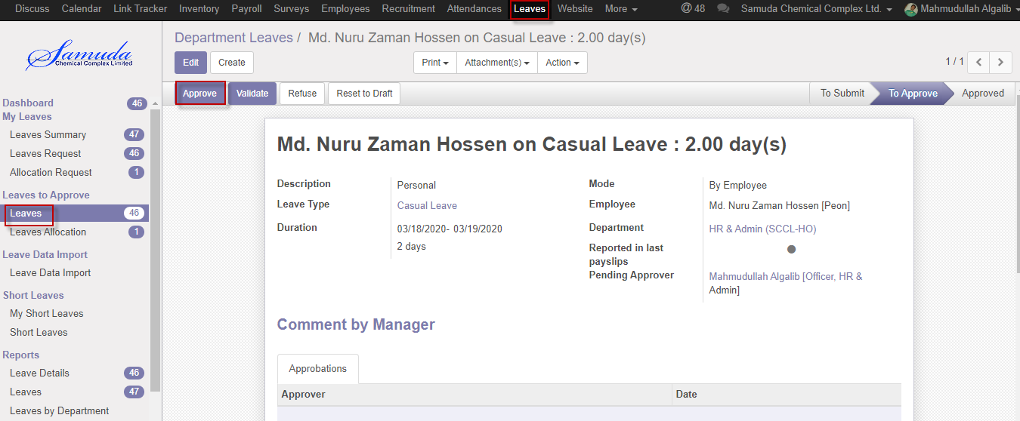

Figure: A Leave Request Final Approval

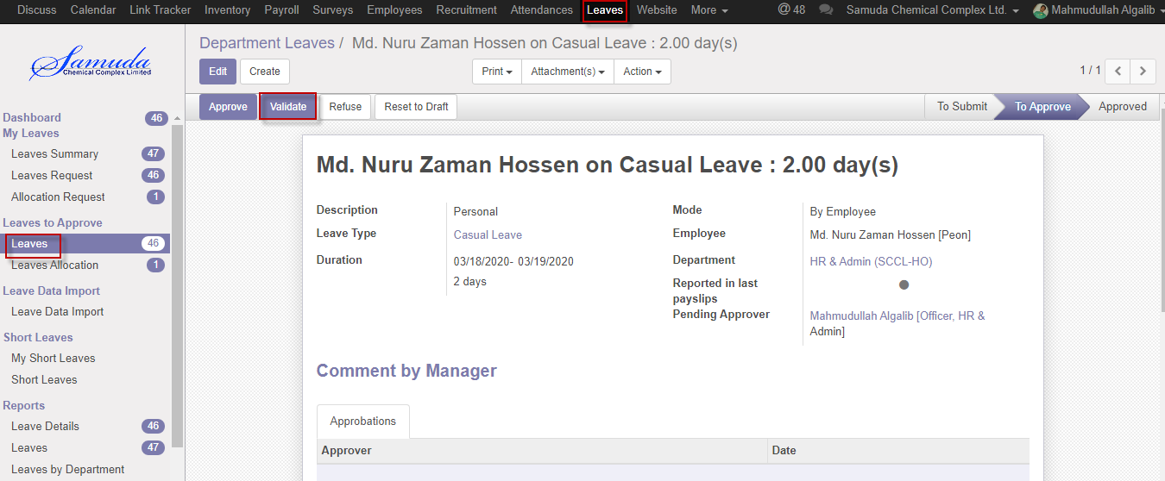

Figure: A Leave Request Validate

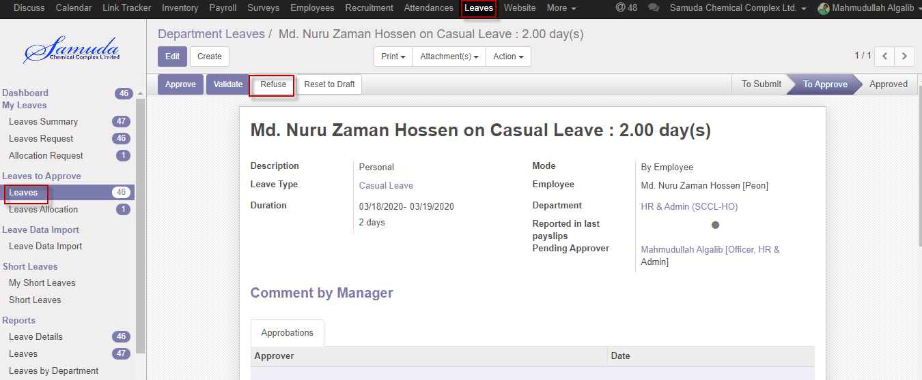

Figure: A Leave Request Refuse

# 4. Leave Allocation Request Approval by Department Manager/supervisor

## 4.1 First Approval Leave Allocation Request by Department Manager/supervisor

After apply the leave allocation request “Department Manager/supervisor” will get the notification. Department Management can update number of leave day(s) before approval. After Department Manager Approval, Unit HR will get notification.

Here Department Manager/supervisor can first approve the leave allocation request by click on **Approve** button.

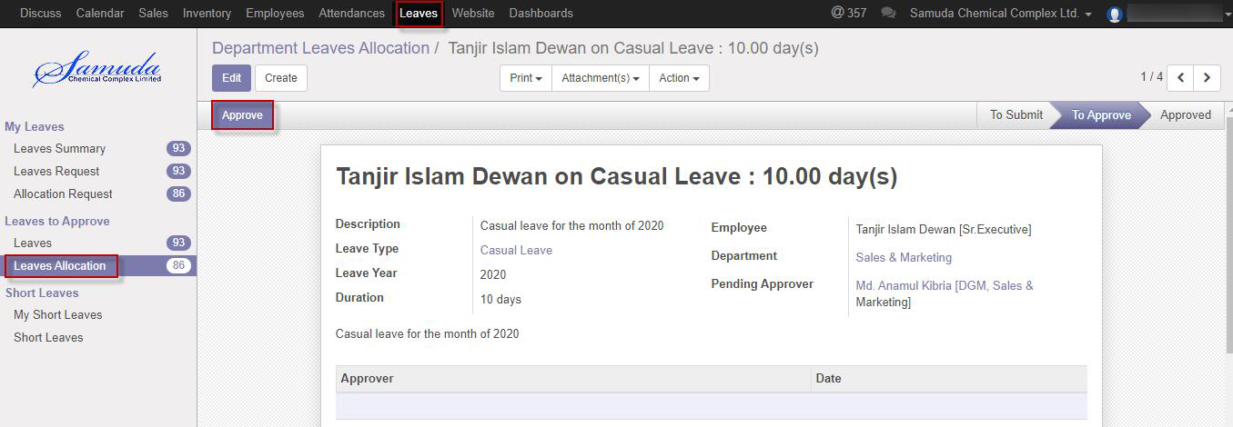

Figure: Leave Allocation Request Approval

# 5. Short Leave Request

Supervisor/In charge is capable to his/her own short leave request. And he/she will approve short leave request under his all employee against.

## 5.1 Create Short Leave Request

Short Leave is for urgent private business that occurs without notice. Short leave can be used for an emergency purpose. For create a short leave request, we have to go **Leaves** menu then create a Short Leave Request.

To create new Short Leave Request, Using the menu **Leave ‣ Short Leaves ‣ Short Leaves** click **Create**.

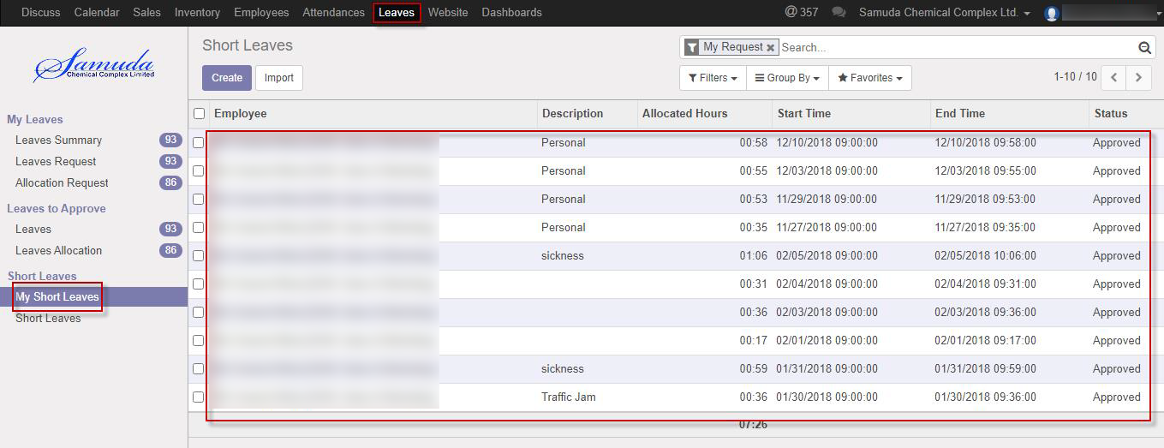

Figure: Short Leaves List View

You can set the following information:-

**Description:** Enter some description.

**Duration:** Select duration of leave.

After entering the Short Leave Request information click **save**.

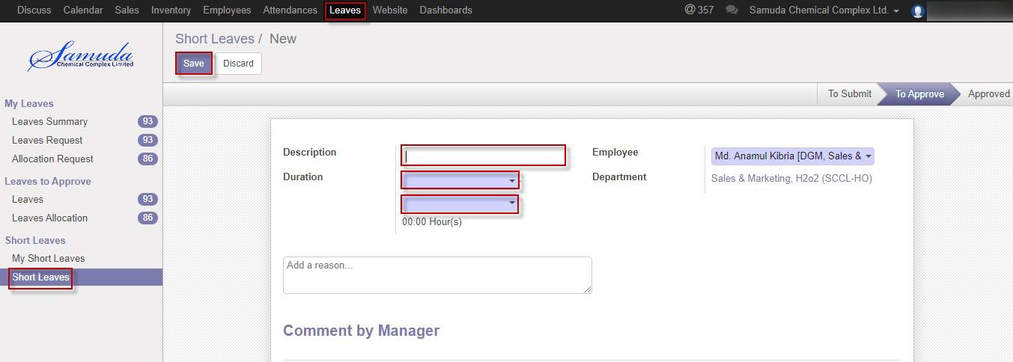

Figure: Create a Short Leave Request

After apply the Short leave request unit HR will get the notification. Unit HR can approve or Refuse the short leave request. He can update number of Hour’s before approval. After Manager Approval, Unit HR will get notification. Unit HR Can Approve or Refuse the short leave request. After that requested short leave will finally approve.

# 6. Short Leave Request Approval by Department Manager/Supervisor

## 6.1 First short Leave Approval Request by Department manager/supervisor

After apply the short leave request “Respective department manager/supervisor” will get the notification. Respective Manager or Unit HR Can first/final approve the leave request. That’s approve will final approve if no other employee none the set custom chain. Respective Management can update number of leave day(s) before approve. After department Manager Approval, Next hierarchy user will get notification.

To see the employee short leave request use the menu **Leave ‣ Short leave**

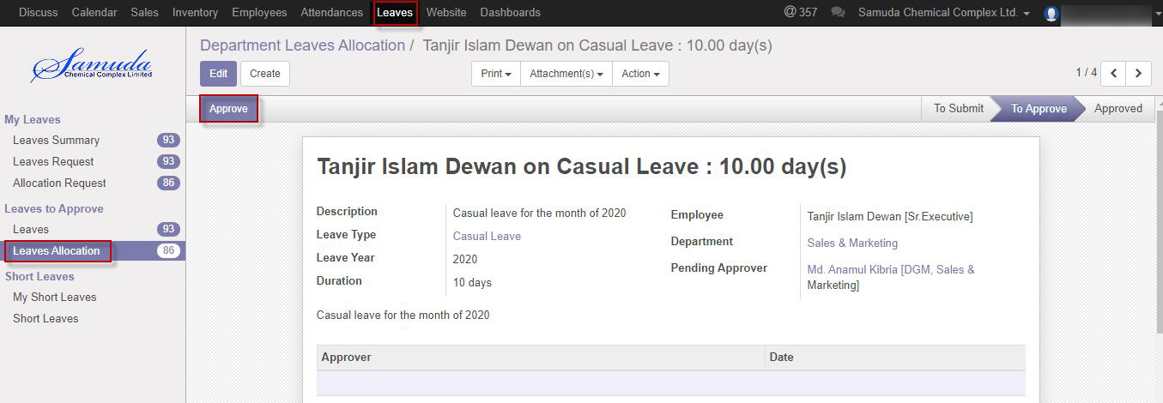

Figure: Short Leave Request list view

Department manager/supervisor can approve employee’s short leave request. Department Manager can see all leave request there **Leaves ‣ Short leave**

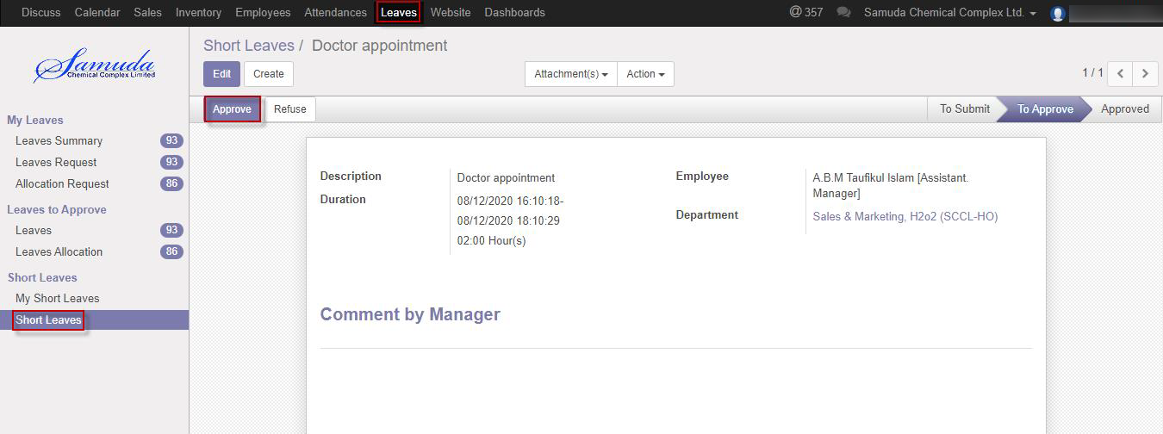

Figure: Short Leave Request First Approval

Here Department Manager can first approve the leave request by click on **Approve** button. He can update number of leave day(s) before approval.

Department Manager/supervisor can refuse short leave request by click **Refuse** Button.

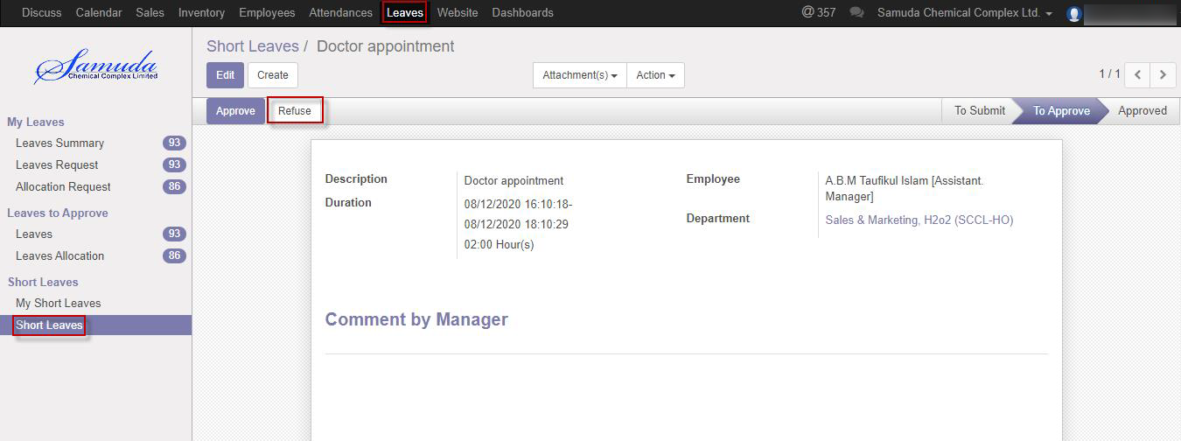

Figure: Short Leave Request Refuse

# 7. Attendance

Supervisor/In charge is capable to his/her own Manual attendance request. And he/she will approve Manual attendance request under his all employee against.

## 7.1 Create Manual Attendance

Sometimes employees work outside of office for this reason he/her can’t sign in or sign out. To solve this problem employee can request to Unit HR by this manual attendance process.

We can create manual attendance using the menu **Attendances ‣ Manual Attendances ‣Manual Attendances Batches** and click **Create.**

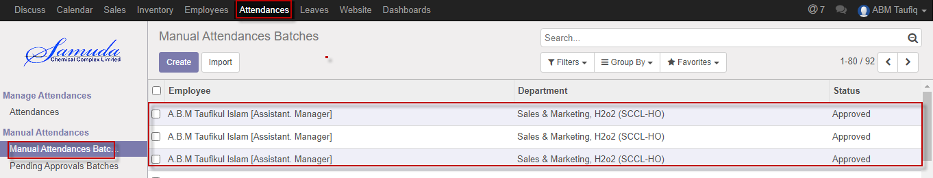

Figure: Manual Attendance batches list view

We need to set the following:-

**Employee**: Employee name will come auto.

**Department**: Department will come auto.

**Sign Type:** Select a sign type.

**Check In:** Work starting time.

**Check Out:** Work closing time.

After entering all information click **Save & Confirm**.

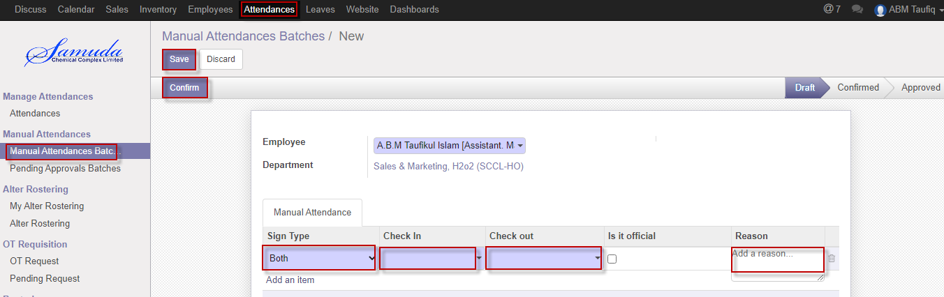

Figure: Create a Manual Attendance batches

After apply the Manual attendance batches Unit HR will get the notification. Unit HR can approve or Refuse the Manual attendance batches. He can update before approval. After Manager Approval, Unit HR will get notification. Unit HR Can Approve or Refuse the Manual attendance batches request. After that requested Manual attendance batches will finally approve.

# 8. Manual Attendance Batches Request Approval by Department Manager/Supervisor

## 8.1 Pending Manual Attendance batches

Department manager/supervisor can see all of employee pending manual attendance batches request.

Using the menu **Attendance ‣ Pending Approvals batches**.

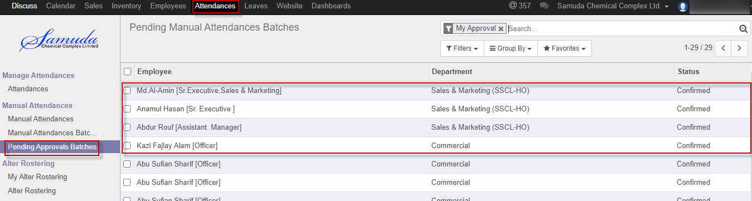

Figure: Manual Attendance batches Pending Approval List View

## 8.2 Approval Manual Attendance Request by Department manager

After apply the manual attendance request “Department Manager/supervisor” will get the notification. Department Manager/supervisor can approve the manual attendance batches request.

To see the employee manual attendance request use the menu **Attendance ‣ Pending Approvals batches**. Here Department Manager can first approve the manual attendance batches request by click on **Approve** button.

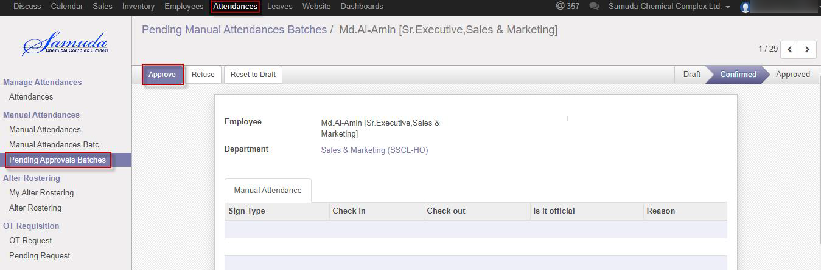

Figure: Manual Attendance batches Request Approval

Department Manager can refuse manual attendance request by click **Refuse** Button.

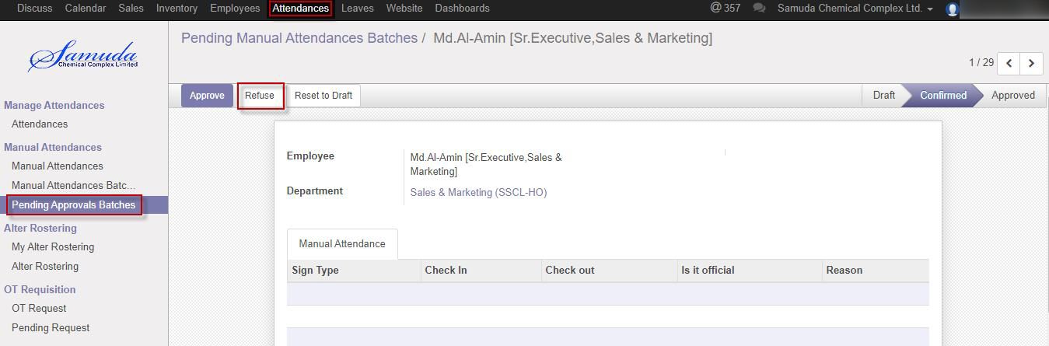

Figure: A Manual Attendance batches Request Refuse

## 8.3 Create Alter Rostering

Sometimes employees want to change his/her shifting and they want to request Unit HR. For solving this problem employee can request to Unit HR by this Alter Rostering process.

Supervisor/In charge is capable to his/her own Alter rostering request. And he/she will approve Alter roster request under his all employee against.

We can create alter rostering using the menu **Attendances ‣ Alter Rostering ‣ My Alter Rostering** click **Create.**

You need to set the following:-

**Employee**: An employee name.

**Alter Date:** A date for attendance.

**Duty Start:** A work stating time.

**Duty End:** A work closing time.

**OT Start:** A work over stating time.

**OT End:** A work over closing time.

After entering the alter rostering information click **Save**.

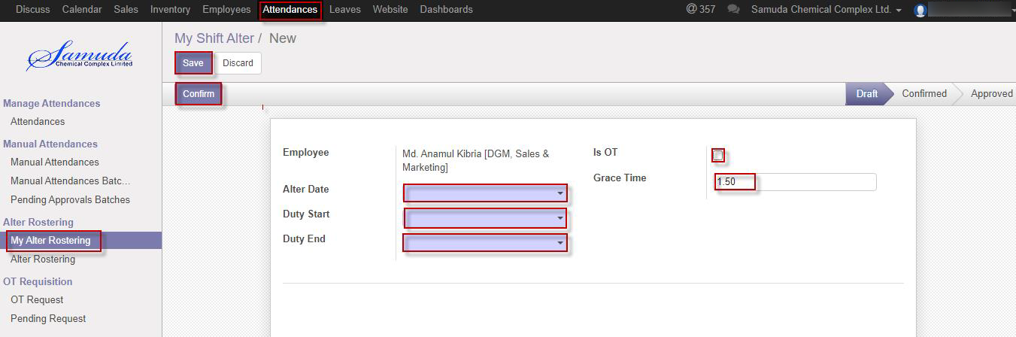

Figure: Create a Alter Rostering

After apply the Alter Rostering request Unit HR will see the request on Alter Rostering menu. Unit HR can approve or refuse the Alter Rostering request. After that requested Alter Rostering will finally approve. After final approval user can see on my Alter Rostering menu.

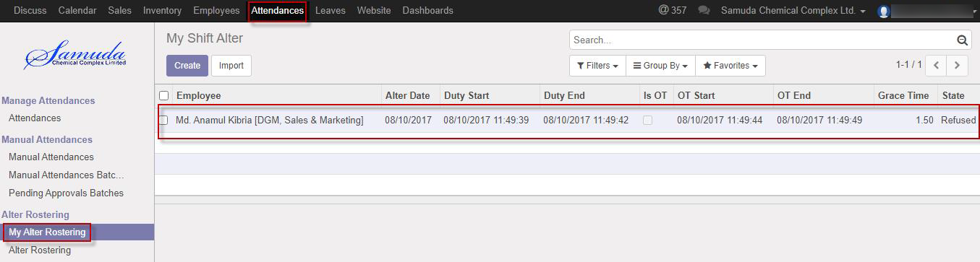

Figure: Alter Rostering Status

## 8.4 Approval Alter rostering Request by Department manager/Supervisor

After apply the Alter roster request “Department Manager/supervisor” will get the notification. Department Manager/supervisor can approve the Alter roster request.

To see the employee Alter roster request use the menu **Attendance ‣ Alter roster**. Here Department Manager/supervisor can first approve the Alter roster request by click on **Approve** button.

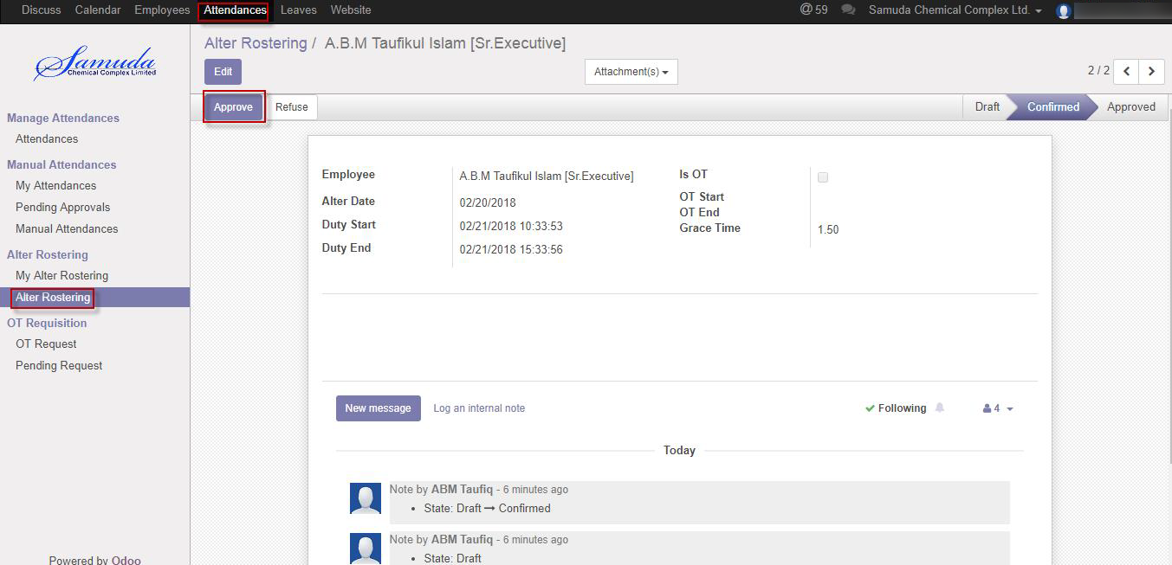

Figure: Alter roster request Approval

Department Manager/supervisor can refuse Alter roster request by click **Refuse** Button.

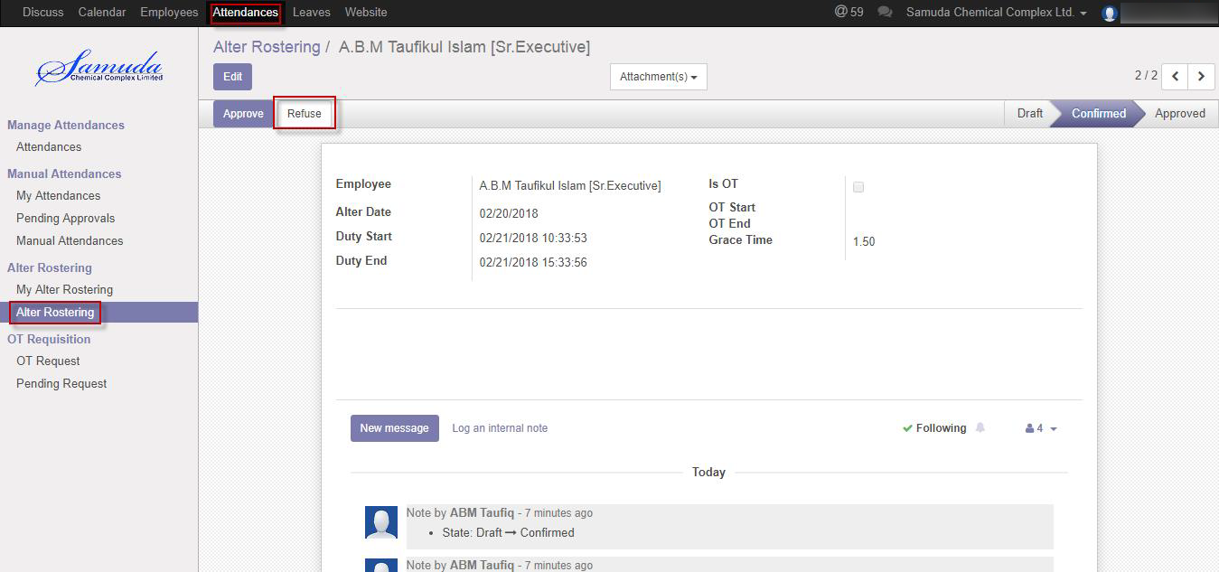

Figure: A alter roster Request Refuse

# 9. OT Requisition

Supervisor/In charge is capable to his/her own OT requisition request. And he/she will approve OT requisition request under his all employee against.

## 9.1 Create a OT Request

Sometimes employees want to extra overtime work that’s why he/she have to request Manager. To solve this problem employee can request to Manager by this OT Requisition process.

We can create OT Request using the menu **Attendances ‣ OT Requisition ‣ OT Request** and click **Create.**

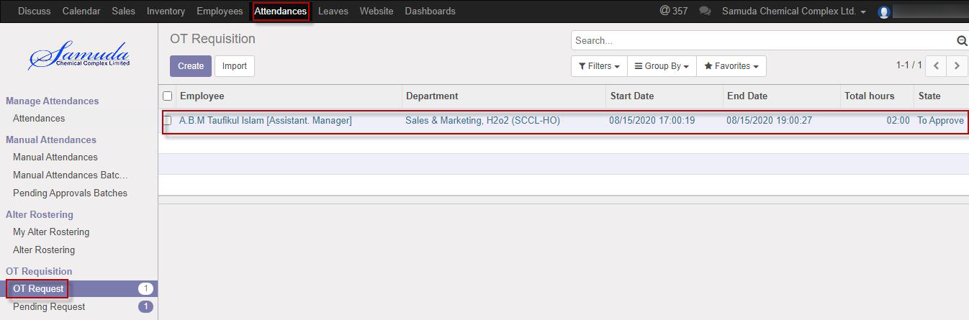

Figure: OT Request List view

We need to set the following:-

**Employee**: An employee name.

**Department**: Automatically select a department.

**Start Date:** Work starting time.

**End Date:** Work closing time.

After entering all information click **Save**.

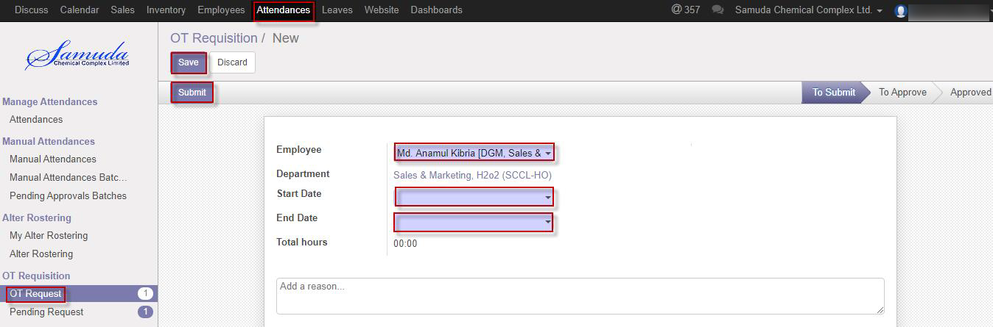

Figure: Create a OT Request

After apply the OT requisition Unit HR will get the notification. Unit HR can approve or Refuse the OT requisition. He can update before approval. After Manager Approval, Unit HR will get notification. Unit HR Can Approve or Refuse the OT requisition request. After that requested OT requisition will finally approve.

# 10. OT Request Approval by Department Manager/Supervisor

## 10.1 First OT Approval Request by Department manager/supervisor

After apply the OT request “Respective department manager/supervisor” will get the notification. Respective Manager or Unit HR Can first/final approve the leave request. That’s approve will final approve if no other employee none the set custom chain. Respective Management can update number of leave day(s) before approve. After department Manager Approval, Next hierarchy user will get notification.

To see the OT pending request use the menu **Attendance ‣ Pending request**

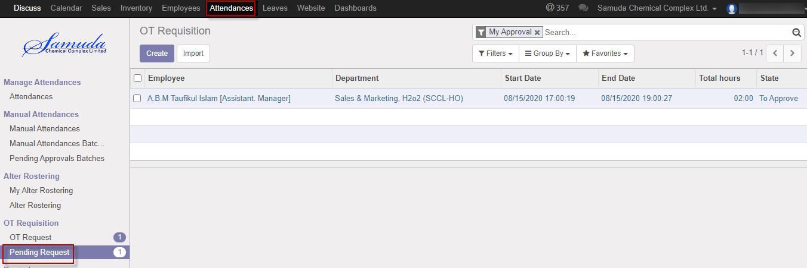

Figure: Pending OT Request list view

Department manager/supervisor can approve employee’s OT request. Department Manager can see all OT request there **Attendance ‣ Pending request**

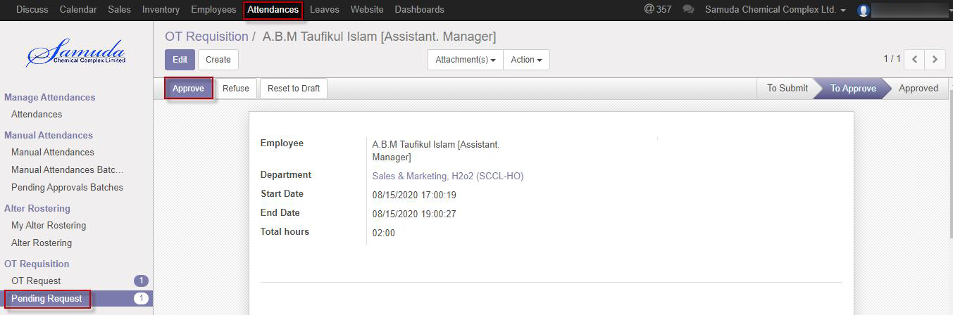

Figure: OT Request First Approval

Here Department Manager/supervisor can first approve the OT request by click on **Approve** button. He can update OT request before approval.

Department Manager/supervisor can refuse OT request by click **Refuse** Button.

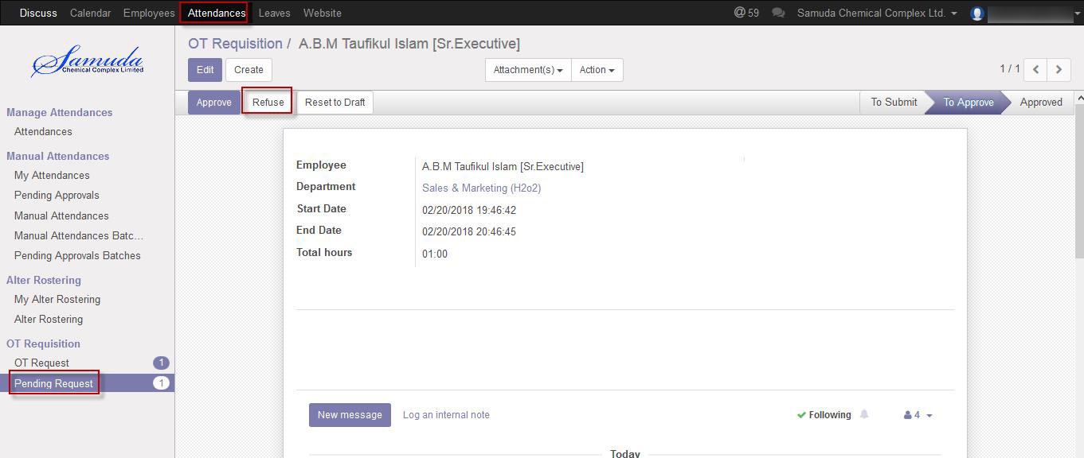

Figure: OT Request Refuse